Measuring public transit transfer risk using high-resolution schedule and real-time bus location data

Luyu Liu and Harvey J. Miller[1]*

Department of Geography and Center for Urban and Regional Analysis

The Ohio State University, Columbus, Ohio, USA

**Abstract**

Transfers between routes in a public transit system are important for many transit users. Missing transfers due to public transit delays can impose substantial time penalties on these users. However, few studies assess the risk and consequences of missing transfers based on on-time performance and delays in the real-time context. Leveraging high-resolution schedule and real-time transit big data, we develop two measures to assess transfer risk and time penalties in a public transit system. *Transfer Risk* (TR) measures the empirical probability of missed transfers between two specified routes over a designated time period and *Average Total Time Penalty* (ATTP) shows overall time loss compared to the schedule. We illustrate these measures based on two sources of schedule and real-time vehicle data from the transit authority in Columbus, Ohio: public General Transit Feed Specification (GTFS) and administrative Automatic Passenger Counter (APC) data. We aggregate, visualize, and analyze each index under different spatial and temporal resolutions. We also simulate the impacts of dedicated bus lanes on the overall transfer performance and different types of transfers. Results demonstrate the potential to apply the TR and ATTP indexes to assess the impacts of delays on transfers and guide planning and decision making to improve on-time performance.

**Keywords**: Transfer; Public transit system; GTFS; Transfer real-time performance.

1. **Introduction**

Transfers between routes are an often necessary component of using public transit. The expansion of city footprints can make long and direct routes difficult and costly (Knoppers & Muller, 1995), making transfers between scheduled public transit routes an important component of the system. However, transit delays, defined as a positive deviation of a transit vehicle’s actual arrival time from the scheduled time, are inevitable due to traffic, malfunctions, and other circumstances. A transit delay causing a user to miss an intended transfer between routes, potentially impose significant time penalties and making the system less functional to users.

Transfers can be a useful component that improves the usability of public transit systems (Walker, 2012). However, transfers have been neglected by many public transportation planners and administrators (Iseki & Taylor, 2009). To make transfers and public transportation more reliable, researchers are assessing, analyzing, and optimizing transfer activities, transfer nodes efficiency, and transit system design and administration. Previous research focuses on the users’ experience and the design of the transfer nodes, using methodologies such as user-based GPS sampling, survey and statistic modeling (Guo & Wilson, 2004, 2011; Han, 1987; Sun, Rong, Ren, & Yao, 2007; Sun, Rong, & Yao, 2010). More recent research expands data sources to include smart card data and real-time feed data (Jang, 2010; Nesheli & Ceder, 2015; Nishiuchi, Todoroki, & Kishi, 2015). However, there are few papers proposing systematic measurement for transfer performance, especially using newly available high-resolution data sources such as real-time vehicle locations. Measures and analytics to help understand the impact real-time public transit system performance on transfers can be useful for operational, planning and administration purposes.

In this paper, we develop measures and analytics for the evaluation of the transfer performance in public transit systems using high-resolution schedule and real-time vehicle location data. *Transfer Risk* (TR) measures the empirical probability of missing transfers based on historical data and *Average Total Time Penalty* (ATTP) shows overall time loss compared to the schedule. We implement these measures using data collected from the Central Ohio Transit Authority (COTA) bus system in Columbus, Ohio. We explore the patterns of TR and ATTP at different levels of spatial and temporal resolution. We also simulate the impact of dedicated bus lane on transfer risk and penalties. The results demonstrate the potential to apply the TR and ATTP indexes to assess the impacts of delays on transfers and guide planning and decision making to improve on-time performance.

In the next section of this paper, we first review the previous work about the transfers in transit systems. Then, we introduce our data sources and methods, including the development and implementation of the new transfer measures. Last, we show the results of the spatial and temporal analyses and the dedicated bus lane simulation.

1. **Literature review**

This literature review covers two aspects of measuring and analyzing public transit transfers. We first discuss data sources, including traditional manual-based data sources such as global positioning system (GPS)-based trajectory samples and surveys, and automatically generated data, including General Transit Feed Specification (GTFS) schedule and real-time feeds, and smart card data (Ceder, 2007). Following this, we discuss research that uses these data for two purposes, namely, measurement and system optimization.

* 1. Deliberate versus byproduct data

**Deliberate data.** Traditionally, studies of public transit transfer properties and behaviors use data collected deliberately for specific research questions, often using dedicated GPS receivers and survey instruments. While these data are valuable, there are several issues that limit the usefulness of studies based on these data sources.

One issue is the lack of universal standards and definitions, making comparison and the generality difficult. Different transfer studies have varying definitions of transfers and their data (Guo & Wilson, 2004), limiting comparability. Studies using deliberate data also have heterogeneous, study-specific data sources that may be difficult to reproduce in other settings.

Another issue is that most deliberate data are expensive and time-consuming to collect. For example, Guo and Wilson (2011) created and maintained special purpose station inventory, direct enquiry and field survey databases. This requires substantial time and resources, often for a relatively small volume of data. Therefore, it can be challenging to cover the entire public transit system well, both spatially and temporally, using deliberate data sources. On the other hand, sampling strategy with a small dataset works well, while it is also fragile without representativeness (Miller & Goodchild, 2015).

An example for deliberate data is stated preference (SP) data. Derived from surveys, SP data is widely used to support mode choice models (Guo & Wilson, 2011). Although many transfer assessment studies use SP data (Wardman, 1998), the choice dimension is typically small, meaning that SP data may not be able to capture the full diversity of transfer situations (Bovy and Stern 2012). Other semi-quantitative data collecting methods, such as on-board questionnaires (Bamford, Carrick, & MacDonald, 1984), can also lack precision and reliability. The result of these imprecise data sources is that most studies provide synoptic assessment for the entire system since it is difficult to have a detailed assessment in a higher spatial or temporal resolution (Guo & Wilson, 2011).

**Byproduct data.** In the past, detailed and real-time data about public transit was difficult to acquire (Dessouky, Hall, Nowroozi, & Mourikas, 1999). However, this has changed due to the development of new data collection and sharing technologies, often used to support activities such as operations and customer relations rather than scientific research. The widespread application of new data capture, data storage, computational infrastructure and information and communication technologies (ICTs) provide the technical support for what is often labeled *Big Data* (Hilbert, 2016). The definition of Big Data is diverse; a commonly accepted definition encompasses the “three Vs”: large volume, high variety, fast velocity (Ayed, Halima, & Alimi, 2015; Chen, Mao, & Liu, 2014). However, as Miller & Goodchild (2015) argue, in many applications, especially in urban science, the unique and valuable characteristic of Big Data is ubiquity: its widespread coverage and availability, often as a byproduct of digitally-enable operations and activities.

In the domain of the public transit, inexpensive GPS receivers and wireless communication allow widespread tracking of vehicle locations in real-time. Meanwhile, the World Wide Web combined with data services allow sharing schedule, real-time vehicle location, and ridership data, such as automatic vehicle location (AVL) and automated passenger counter (APC) data. It makes precise and comprehensive data available. In addition, these data are collected automatically on an ongoing basis by public transit authorities, meaning they are readily available without additional and prohibitive cost or effort. This technology revolution allows the possibility of more detailed investigation of transfer performance in a transit system.

However, big data also has limitations. As suggested by the characteristic “high variety,” these data are often heterogeneous in terms of structure, quality and support: including unstructured data such as video and text, diverse data sources, lack of metadata, and lack of quality control all make big data challenging from a scientific perspective (Miller & Goodchild, 2015). Accordingly, standard protocols for transit schedule and real-time data, such as General Transit Feed Specification (Google Developers, 2016, 2018) and Service Interface for Real Time Information (Transmodel, 2019), were introduced to help solve the problems.

Besides AVL data, some studies also leverage user-based data like smart card data to study transfers in the public transit systems (Jang, 2010; Nishiuchi et al., 2015). Jang (2010) discusses the use of smart card data potential for transportation planning, especially travel and transfer analysis. Nishiuchi et al. (2015) used DESUCA smart cards data to measure the transfer efficiency in Kochi city, Japan. An advantage of smart card data is that it is linked to humans not vehicles. A disadvantage is limited availability compared to the open data sources such as GTFS.

* 1. Measuring and analyzing public transit transfers

We can classify public transit transfer studies into two major categories, namely, transfer measurement and transfer optimization.

**Transfer measurement.** Many studies concentrated on measuring different aspects of transfers and defined different indices based on one or several transfer attributes. For example, Nishiuchi et al. (2015) used Data Envelop Analysis (DEA) model to reference multiple indices to evaluate the efficiency of user transfers between transportation systems. This study concentrated on the transfer stations’ commuting efficiency using users’ smart card data. Hadas & Ranjitkar (2012) combined transfer connectivity and travel time to representing the quality of the transfer. They sort the transfers by quality standards into several categories and measured the transfer’s effectiveness in terms of travel time and transfer by mode of the two transfer stops.

Guo & Wilson (2011) assessed the cost of transfer in transit system based on both users’ and operators’ perspective. The paper developed an index based on path choice and labeling approach and applied it to the London Underground system in London, UK. In the case study, the paper computed each transfer nodes’ average time and economic cost per capita and their effectiveness in London Underground system. They used four multinomial logit models to measure the effectiveness of each transfer node.

Some research analyze users’ perceptions and attitudes about transfers (Algers, Hansen, & Tegner, 1975; Guo & Wilson, 2004; Han, 1987; Hunt, 1990; R. Liu, Pendyala, & Polzin, 1997; Planning & Transportation, 1997; Wardman, Hine, & Stradling, 2001). These studies focus on measuring transfer penalties; these penalties encompass a broad range of factors such as walking time, number of transfers in a single trip, waiting time, ticket fare, and other environmental factors.

Kujala et al. (2018) analyzed travel time and transfer in Helsinki, Finland across multiple dimensions. They calculate pre-journey waiting time, journey duration, and number of required transfers for all Pareto-optimal journeys between all origin-destination (OD) pairs to calculate accessibility for Pareto-optimal journeys with different number of possible transfers.

**Transfer optimization**. The synchronization of bus timetables is a sub-problem of bus network planning, and it has been proven to be NP-hard, meaning it is difficult to solve exactly (Ibarra-Rojas & Rios-Solis, 2012). Methods have been devoted to developing transfer optimization algorithms for planning and optimization purposes, with the objective of optimization includes minimizing travel and waiting times and maximizing synchronization. For example, Ceder, Golany, & Tal (2001) develop a heuristic algorithm to maximize the synchronization in a public transit system. Jang (2010) utilizes smart card data to illustrate that transit authorities can improve the service at some critical transfer nodes.

Several studies investigate the real-time (tactic-based) optimization of system operations (Liu, Ceder, Ma, Nesheli, & Guan, 2015; Nesheli & Ceder, 2014; Nesheli, Ceder, & Liu, 2015; Nesheli, Ceder, & Gonzalez, 2016; Nesheli, Cedera, & Hassold, 2014). For example, Nesheli et al. (2015) develop a performance indicator system based on an agent-based model to simulate real-time performance. The study uses GTFS schedule and OpenStreet map data, demand data derived from survey, and transit vehicles data to develop a real-time optimization system. However, some results were not involved with the actual real-time data. Consequently, the real-world accuracy of these models is still debatable.

Due to the lack of real-time data, few papers assess transfer real-time performance and risk of missing transfers due to bus delays, as well as the performance’s variance and spatiotemporal patterns. Progress in data availability, real-time monitoring and other smart city technologies are making this topic an area of active investigation: researchers can now conduct more detailed analysis and develop more precise measures and models of public transit transfers (Hadas & Ranjitkar, 2012; Kujala et al., 2018). This paper contributes to this literature by developing measures of transfer risk and transfer time penalties using high-resolution real-time data sources.

1. **Methodology**

This section discusses the methodology. We first describe our data sources; then we define public transit transfers from a space-time perspective and conceptualize the impact of vehicle delays as a problem in transfer synchronization. Then, we discuss the methods involved in transfer risk measurement and analysis.

* 1. Data sources

In this paper, we leverage two datasets for the development and implementation of the transfer risk measures and analytics.

**General Transit Feed Specification (GTFS) data.** General Transit Feed Specification (GTFS) is a combination of two data standards defined by Google: GTFS static and GTFS real-time expansion. GTFS static, also named static transit, reports the schedule data of a public transportation system. GTFS static is now the *de facto* standard for public transportation schedules and associated geographic information (Google Developers, 2016). Public transit system administrations are encouraged to share their GTFS static publicly, regularly, and precisely. Many of them are sharing their data: this is not limited to large transit authorities such as the Metropolitan Transportation Authority (MTA) in New York City. Already by 2010, almost 85% of transit miles traveled in the U.S were covered by open data published by transit authorities (Antrim & Barbeau, 2013).

GTFS real-time expansion provides frequently updated vehicle location data. GTFS real-time includes two components: buses’ location real-time data and the trip updates, which contains vehicles’ arrival and departure time at every sequential stop. Moreover, the temporal resolution can be as high as 1 min (Kujala et al., 2018). GTFS overcomes the disadvantages of both traditional data and unclean big data: small volume, low velocity, lack of standards, and limited system coverage.

However, despite all the valuable features, GTFS is not perfect. In particular, GTFS’s *temporal accuracy* can be low compared with other sources such as automated passenger count data (discussed below). This is because GTFS real-time data feed is updated based on a static temporal interval, not based on the actual events of a public transit vehicle entering and leaving a designated stop. Consequently, the actual arrival/departure time may be different from the final time recorded in the GTFS data.

**Automated Passenger Count (APC) data.** Due to the temporal uncertainty of GTFS data, we also utilize another source. Automated Passenger Counting (AOC) data is generated by devices that are installed on the vehicles to track and report transit ridership (Chu, 2010; Transit Wiki, 2019). These data often contain the arrival time and departure time collected at each stop.

A major advantage of APC data compared to GTFS data is its higher temporal accuracy: the arrival and departure time is measured at the stop and updated promptly based on the events, instead of updated according to a specified temporal interval. However, it is important to point out that APC data are not open. As administrative data, APC data are not available for the public and other transit mobile applications; as an internal data format, they lack a universally accepted and manageable data protocol. These two characteristics make the dataset hard to reuse and expand to other systems. Moreover, APC data does not have widespread coverage of the whole system. Typically, a subset of public transit vehicles are installed with APC devices; consequently, we cannot conduct any analyses solely based on APC data.

To make it feasible to utilize APC data as a possible data source and compensate for the mentioned drawbacks, we merged the raw APC data and the GTFS data into a new combined dataset. We enumerated all GTFS trips while querying the APC database: if the corresponding trip is in the APC database, we will override the record in the GTFS database. Below, we will provide results based on both the original GTFS and the merged APC-GTFS dataset.

* 1. Transfer definition

All transfers can be divided into several two-stage sub-transfers, which consist of two trips: the *generating trip* and *receiving trip*. Within each two-stage transfer, a user first boards a bus to start the generating trip, then alights to catch the next bus to start the receiving trip until the user arrives her/his final destination. Figure 1 provides an illustration using a time-space diagram. Defined by Hadas and Ranjitkar (2012), two-stage transfers could be categorized by a) street-crossing transfer; b) sidewalk transfer; c) non-walk transfer; d) one-leg trip (Hadas & Ranjitkar, 2012). Based on this categorization, we can generalize the transfers as: a) *non-walking transfer*, which does not require a walking process for the transfer, and b) *walking transfer*, which requires walking from the generating trip’s destination stop (which we label the *generating stop*) to receiving trip’s starting stop (the *receiving stop*).

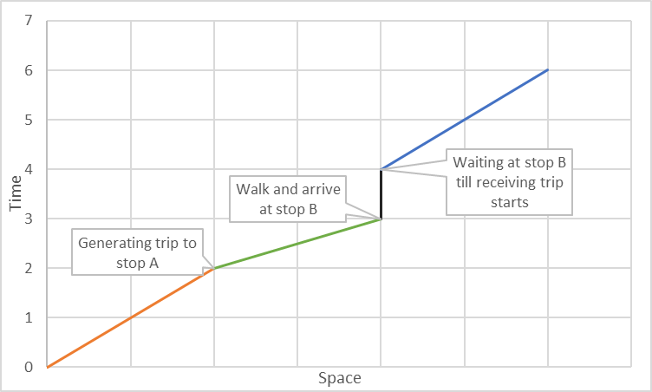

Figure 1 Time-space diagram of a typical two-stage transfer.

* 1. Transfer synchronization, desynchronization and time penalties

**Synchronization and desynchronization.** We further conceptualize transfers as a process of synchronization among: i) the generating trip brings passengers to the generating stop; ii) transition of users to receiving stop; iii) the receiving trip picks up passengers at receiving stop. Transfers are not like normal transit trips in terms of passenger participation: passengers have no control of the performance of transfers during this process, since both actors of the synchronization are transit vehicles.

Due to factors such as traffic congestion, weather, road construction and unforeseen events such as vehicle crashes, delay is inevitable in a public transit system. Delay can result in inconsistent arrival and departure times hence the desynchronization of scheduled generating and receiving trip; Figure 2 provides an illustration. For each transfer, we can measure the time penalty when the receiving bus is leaving; this is the time point when the desynchronization happens. During the synchronizing process between the generating and receiving trip at the receiving stop, the actual transfer can differ from the schedule according to the relative temporal order of the two trips arrival/departure time.

Due to the desynchronization, the actual receiving bus can be different from the scheduled receiving bus. The schedule of all buses running on the same route can be conceptualized as an array of trips (a *trip sequence array*). We assume the passenger will always take the first available bus. If the generating bus is sufficiently late, the passenger will miss the scheduled bus and need to take a later scheduled bus. Likewise, if the receiving buses are sufficiently late, the passenger can catch an earlier receiving bus in the trip sequence array. We developed an integer variable, *desynchronization degree* (DD), to measure a transfer’s desynchronization in the trip sequence array:

|  |  |  |
| --- | --- | --- |
|  | $$\begin{aligned}DD=\left\{\begin{aligned}0, \text{if actual bus is scheduled bus} \\ n, \text{if actual bus is }{\text{n}}_{\text{th}}\text{ after scheduled bus in the sequence array} \\ -n,\text{ if actual bus is }{\text{n}}_{\text{th}}\text{ before scheduled bus in the sequence array}\end{aligned}\right.\#\end{aligned}$$ | (1) |

|  |  |  |
| --- | --- | --- |
|  |  |  |

**Transfer time penalties.**

|  |  |  |
| --- | --- | --- |
|  |  |  |

TTP represents the total time loss compared to the schedule at the receiving stop. The value shows the synoptic delay when the receiving trip starts, which encompass both generating and receiving bus’s time loss. However, since the synchronization process is involved with two actors, it is also important to determine the corresponding time loss caused by each bus. For example, a large TTP could be because of the receiving bus’s large delay but the synchronization is not disturbed; on the other hand, a large TTP could be also because of the first bus’s delay, which results in desynchronization thus long waiting time.

To quantify this two different types of delay, we decompose TTP as follows:

|  |  |  |
| --- | --- | --- |
|  | $$TTP={ T^{'}}_{r Departure}^{n}-{ T}_{r Departure}^{0}$$ $$=\left({ T^{'}}_{r Departure}^{n}-{ T}_{r Departure}^{n}\right)+\left({ T}_{r Departure}^{n}-{ T}_{r Departure}^{0}\right)$$ $$=d_{r}+\left({ T}_{r Departure}^{n}-{ T}_{r Departure}^{0}\right)$$ $$=d_{r}+ATP$$ | (3) |

where: ${ T}_{r Departure}^{n}$ is the scheduled departure time of the actual receiving bus (DD = n), ${ T}_{r Departure}^{0}$ is the scheduled departure time of the scheduled receiving bus (DD = 0), $d_{r}$ is the delay of the actual receiving bus at the receiving stop.

The second part of the decomposition $\left({ T}_{r Departure}^{n}-{ T}_{r Departure}^{0}\right)$ is defined as *additional time penalty* (ATP), which represents the time cost caused by the transfer desynchronization.

The two parts of TTP’s decomposition, ATP and $d_{r}$, correspond to the time penalty caused by missing the scheduled bus and normal delay of the actual receiving bus. The value of $ATP$ depends on the passenger’s actual arrival time at receiving stop ${ T}_{g Arrival}^{'}$ and the receiving buses’ schedules. If the passenger’s actual arrival time is before the scheduled bus’s departure time (DD = 0), there will be no additional time penalty; if the actual arrival time is after the nth bus’s departure time (DD = n), which can be noted as *n*-*th* receiving bus, then there is an additional time penalty which is worth sum of *n* receiving buses’ headways.

|  |  |  |
| --- | --- | --- |
|  | $$ATP=f\left({ T}_{g Arrival}^{'} , {{ T^{'}}_{r Departure}^{M},…, T^{'}}_{r Departure}^{n},…,{ T^{'}}_{r Departure}^{N}\right)$$ $$={ T}_{r Departure}^{n}-{ T}_{r Departure}^{0}, s.t. { T^{'}}_{r Departure}^{n-1}≤T_{g Arrival}^{'}<{ T^{'}}_{r Departure}^{n}$$ $$=\sum_{i=0}^{n}{h_{i}}$$ | (4) |

where: n is the transfer’s actual DD, M is the lower bound of DD, and N is the upper bound of DD. $\sum_{i=0}^{n}{h_{i}}$ is the sum of headways. The index is applied to both schedule-based and headway-based systems; however, due to GTFS data’s schedule-based nature, we focus on the schedule-based systems in this paper.

**Transfers: The good, the bad, and the ugly.** We classify all transfers into three categories according to their real-time synchronization performance. We can distinguish them by the receiving bus’s desynchronization degree.

* *The good, normal transfers* (DD = 0), as shown in Figure 3 (middle). A passenger getting on a normal transfer will catch the same bus as the scheduled transfer. Under this circumstance, ATP = 0, which means there is no additional time penalty, while the performance can be still different from the schedule due to the normal delay of the receiving trip.
* *The bad, missed transfers* (DD > 0), as shown in Figure 3 (right). Under this circumstance, ATP > 0. The passenger will take a bus after the scheduled bus, hence will suffer from additional time penalty other than normal delay. The missed transfers moreover have several scenarios: 1) generating trip is delayed that the user cannot catch the scheduled receiving bus; 2) the scheduled receiving bus is out of service; 3) the scheduled receiving bus is severely delayed after another receiving bus. Scenario 1 is the most common circumstances. For scenario 2, if the scheduled receiving trip is no longer running, the passenger must take the next bus. Likewise, for scenario 3, a severely delayed bus can be caught up by another bus on the same route scheduled after it. It is natural for users to take the closest bus despite the buses being out of sequence.
* *The ugly, preemptive transfers* (DD < 0), as shown in Figure 3 (left). During a preemptive transfer, instead of the scheduled bus, the user will get on a bus which should have arrived earlier than the passenger at the receiving stop. This is due to delays in the receiving buses. The passenger will naturally take the nearest bus regardless of the schedule. The ATP’s value can be negative, zero or positive, however, a negative ATP will not necessarily suggest a better performance since the TTP can be positive meanwhile.

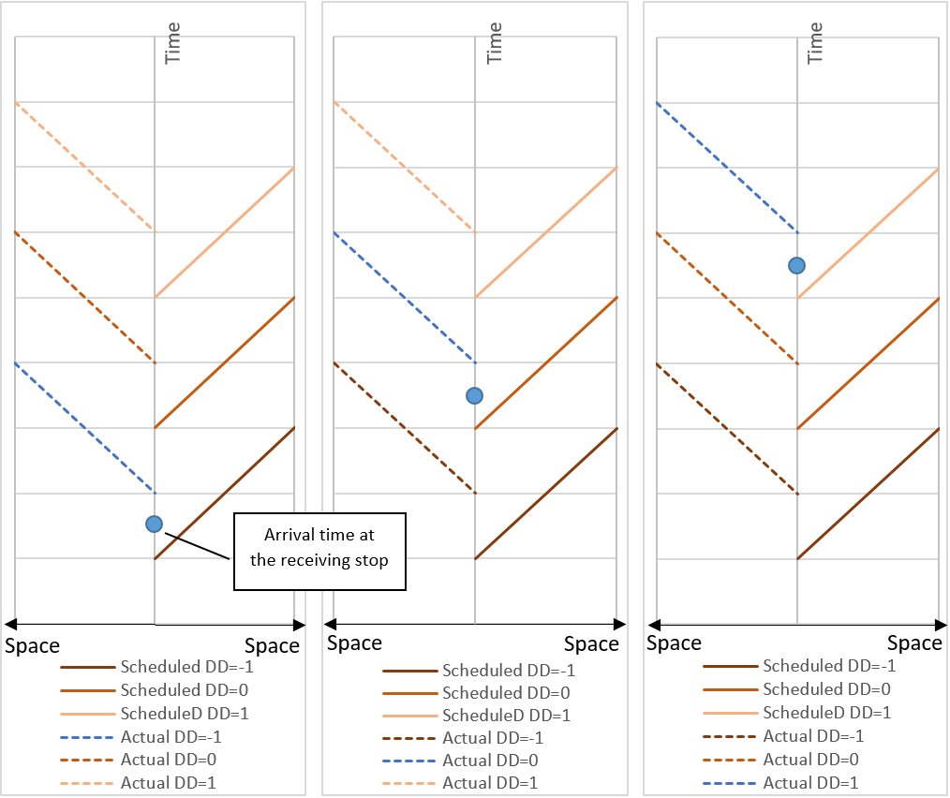

Figure 3 Space-time diagram of three scenarios of a transfer synchronization process (Dash line: actual; solid line: schedule.)

* 1. Defining valid transfers schedule

There are four policies for transfer scheduling in public transit systems: 1) Unscheduled transfers; 2) Scheduled transfers without vehicles waiting; 3) Single holding strategy that lower frequency vehicles wait for higher frequency vehicles; 4) Double holding transfer that both vehicles hold for transfers (Ceder, 2007; Knoppers & Muller, 1995). Many transit authorities, especially those that rely on buses, use an unscheduled transfer policy, meaning there are few explicitly scheduled transfers in the GTFS static data. Moreover, in reality, transit users’ transfer behavior and transit real-time apps will not strictly follow the scheduled transfers.

Consequently, we have to search empirically for possible transfers from the GTFS static data. Theoretically, any two trips at two stops which are proximal enough for users to access can be regarded as a valid transfer. This can be refined with passenger data that shows actual transfers; this is likely to be a subset of the valid transfers. However, the danger with this approach is we may miss a potential transfer if it did not occur in the data.

Based on the data structure in the GTFS data, we define three levels of aggregation: *stop*, *route*, and *trip*. Every trip is run according to a fixed schedule by a bus at a specific time. Trips with a same schedule can be aggregated into a route, and some routes can be bound to a stop. To find transfer schedule from GTFS schedule, we developed a hierarchical searching algorithm in Python and MongoDB environment. Using the algorithm, we derived all possible stops combinations, route combinations, and GTFS trip combinations. Only those combinations with near distance (Euclidean distance < 100 meters) and unique routes are selected for the transfer schedule.

* 1. Other measures

We present several methods to assess the risk of transfers in a public transit system. We measured each transfer using the total time penalty or a binary value that represents whether it has additional time penalty or not. Based on the assessment of single transfer, transfer risk is the proportion of missed transfers based on the empirical schedule and real-time vehicle location data; we can interpret this as an empirical probability of a missed transfer.

The overall *transfer risk* (TR) in the system is:

|  |  |  |
| --- | --- | --- |
|  | $$TR=E\left(a_{i}\right)=\frac{1}{n}\sum_{i=1}^{n}{a_{i}}$$ | (5) |

$$a_{i}=\left\{\begin{aligned}1, if DD_{i}>0 \\ 0, \text{otherwise}\end{aligned}\right.$$

where: *n* represents the number of transfers, and $a_{i}$ is the binary measurement variable of each transfer indicating whether the transfer is missed. A missed transfer is defined as: the actual bus’s desynchronization degree is larger than 0. This also means the user takes a different bus *after* the scheduled bus. We can also measure the *average total transfer time penalty* (ATTP) for the system:

|  |  |  |
| --- | --- | --- |
|  | $$ATTP=E(TTP_{i})=\frac{1}{n}\sum_{i=1}^{n}{{TTP}_{i}}$$ | (6) |

where: $TTP_{i}$ is the measurement of transfer $i$’s total time penalty.

TR and ATTP are a further step towards a smart public transit system: Compared with previous indexes and measuring systems, the spectrum of the proposed measures’ audience is broad: besides academic and administrating purposes, ordinary passengers and open source developers can also be potential users. Thanks to the high-resolution public transit data, we can calculate corresponding performance based on specific transfers as well as overall broad patterns. For example:

* At the application level, users can query each transfer’s performance in their real-time transit apps and react correspondingly. A major concern for users to use transfers is their instability. However, current mainstream transit apps do not show empirical risk and average time loss on their interfaces, especially for transfers which users have no control of. If a proposed transfer’s empirical performance is shown when the apps plan the trip, users can avoid high risk and high penalty route thus save potential waiting time.
* At the operational level, administrators can check the high risk and high time penalty areas and respond. With support of real-time data and the measures in this paper, the transit authorities can make operational changes such as adding additional buses and enforce bus’s time table to reduce transfer risk. Moreover, with the real-time ridership data, administrators can identify the ongoing transfers and plan flexible time table adjustment accordingly.
* At the management level, traffic and city planners can analyze the spatial and temporal patterns of risk and time penalties, and adjust the system accordingly. The patterns of TR and ATTPs can demonstrate important information about the road design, the transit system’s design, and other transport and non-transport factors in the domain of city planning. For example, after a major route adjustment, managers can assess the changes in transfer risk and time penalties. Similarly, traffic planners can compare the risk and penalty indexes before and after the transit route redesign, which can provide substantial evidence to validate and justify the efficiency of the change.
* At the policy-making level, policy makers can compare different public transit systems’ transfer real-time performance across the US. Unlike some composite indexes that are hard to compare with each other, transfer risk and total time penalty are all comparable across different systems. Meanwhile, due to the high reusability and expandability of the indexes and the system, they can be easily implemented and applied to any transit system with published GTFS scheduled and real-time data without major modification.

1. **Analysis**

To validate and implement the indexes and the system, we conducted a case study with GTFS data from Central Ohio Transit Authority (COTA) bus system in Columbus, Ohio from February 2018 to January 2019. Accordingly, we acquired the GTFS schedule and real-time data with the COTA application programming interface. We received APC dataset from May 2018 to January 2019 from COTA system administrators. Figure 4 shows the matching rate from GTFS to APC database; on average, 45.06% of the total records can be matched.

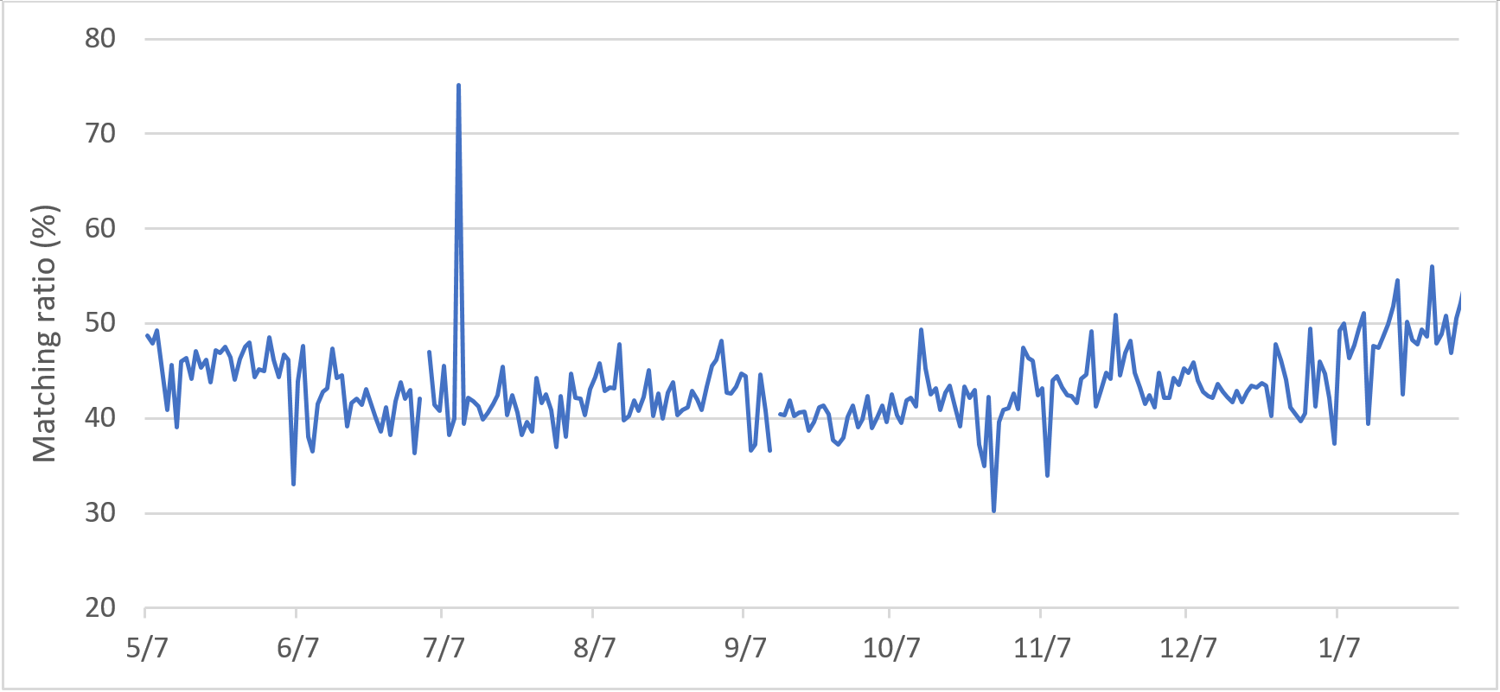

Figure Ratio of matching records from GTFS to APC database

We archived the data using a MongoDB database. The GTFS real-time data, APC data, and their auxiliary databases total nearly one terabyte. Due to this large database size, we optimized and parallelized our code to deal with the subsequent computational difficulties. Using various aggregation methods, we developed different summary measures based on varying spatial or temporal resolutions. To compare the results derived from GTFS and APC data, we present two versions of measures and compare accordingly.

* 1. Spatial patterns

To investigate the spatial pattern of transfer risk, the first thing is spatial aggregation, since *trip patterns* (the finest level of resolution) are too specific and not representative of broader patterns. We can aggregate trip combinations in different ways. Naturally, *route patterns* are useful, which aggregate the trip combinations based on their route schedules, since they measure the empirical performance of the transfers between certain stops and certain routes. *Stop patterns* are also useful since the quality of transfers between stops is assessed and stop combinations are geographically distinguishable, making it especially crucial for visualization. We concentrate on stop patterns in our analyses.

Table 1 shows the descriptive statistics of all the transfers in the COTA bus system. We can observe that APC-GTFS dataset’s result is considerably larger than the original GTFS. Although the mean value is relatively small, however, the standard deviation is substantially large, which suggests the temporal and spatial variation is large.

|  |  |  |
| --- | --- | --- |
|  | Original GTFS | APC-GTFS |
| Average transfer risk | 7.14% | 8.55% |
| Standard deviation of transfer risk | 25.75% | 27.96% |
| Average total time penalty (min) | 3.74 | 4.57 |
| Standard deviation of total time penalty (min) | 12.97 | 15.44 |

Table : Mean and standard deviation of transfer risk and total time penalty for all transfers in the COTA system, February 2018 - January 2019

Figure 5 and Figure 6 show the spatial pattern of the TR and ATTP from February 2018 to January 2019 for both datasets. It shows some differences between TR and ATTP’s spatial distribution, especially on High Street (a major north-south thoroughfare in Columbus, indicated by a red circle in Figure 5 and Figure 6) and downtown area (indicated by a blue circle in Figure 5 and Figure 6). Stops among High Street has relatively higher transfer risk while they also have relatively lower average total time penalty. This is because the headway between buses is small, although the transfers are frequently missed. Similarly, the high ATTP clusters on some roads in downtown area and some periphery roads do not have higher transfer risk. Although the desynchronization cost is low, the original delay can be high, especially for downtown. If a user misses a bus in these locations, that user must wait for a relatively longer time; but these stops have relatively lower risk of missing a scheduled bus.

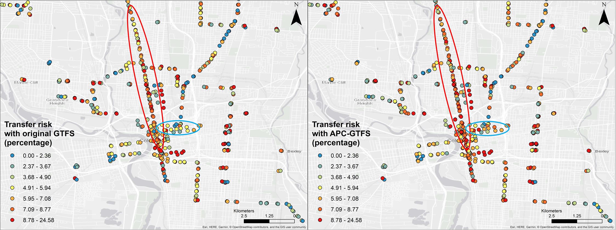

Figure 5 Spatial pattern of TR (in percentage and quantile classification) in 2018

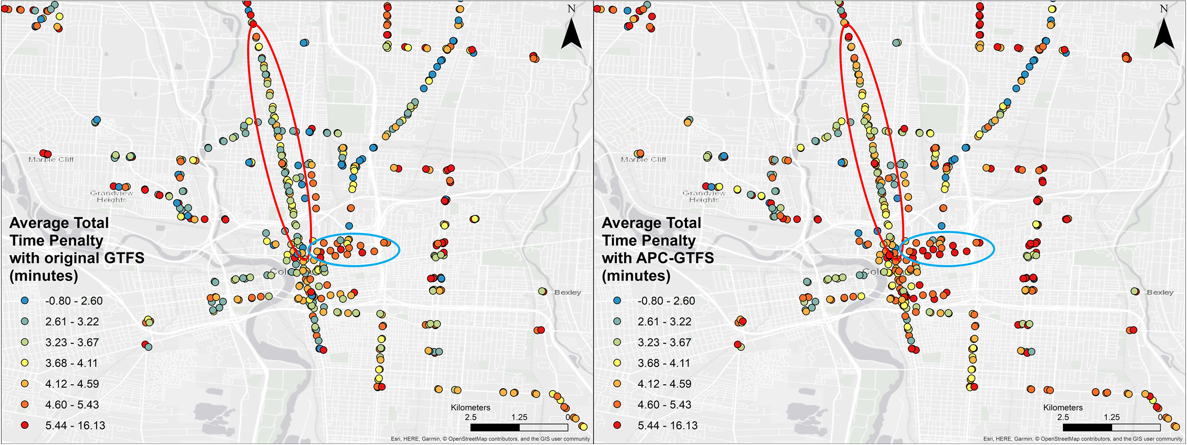

Figure 6 Spatial Pattern of ATTP (in minutes and quantile classification) in 2018

* 1. Temporal patterns

We now examine temporal patterns of transfer risk and time penalties. Figure 7 provides the monthly trends of TR and ATTP for both datasets. Although APC-GTFS’s results are still larger, both datasets suggest a similar changing pattern. July, December, and January show an overall low time penalty pattern. This can be due to better overall traffic conditions during summer and holiday season vacation. August is the worst month to take a transfer; this may be due to the start of an academic year in a city with a massive university campus near the city center.

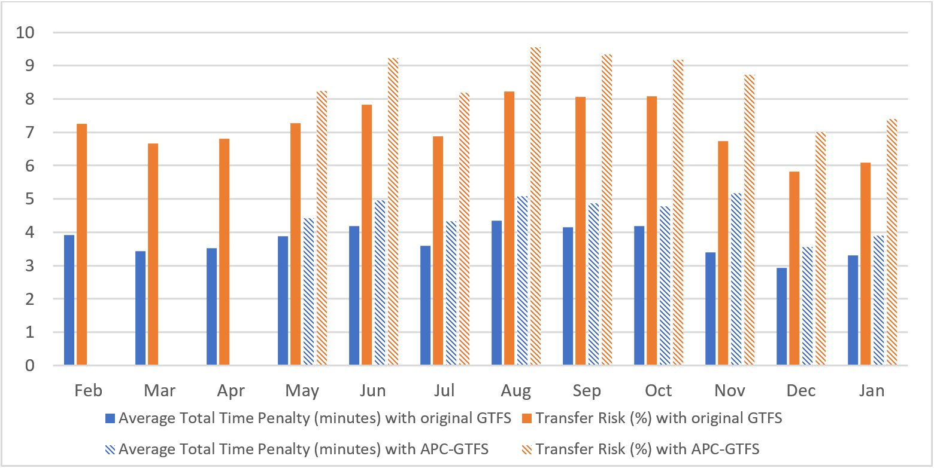

Figure 7 Overall monthly TR and ATTP trend chart in 2018.

Figure 8 provides the trends by day of the week for both datasets. We can see the overall TR and ATTP peak on Friday, and the core of weekdays (Wednesday, Thursday, and Friday) maintains higher levels of risk and penalties due to the overall traffic pattern. TR and ATTP are relatively low on weekends, as would be expected due to lower traffic congestion. TR and ATTP are relatively low on Mondays, possibly due to flexible working schedule and long weekends for some residents, leading to less commuting. However, for APC-GTFS dataset, we observe ATTP on Sundays is second lowest compared to Fridays, which is the lowest for original GTFS dataset.

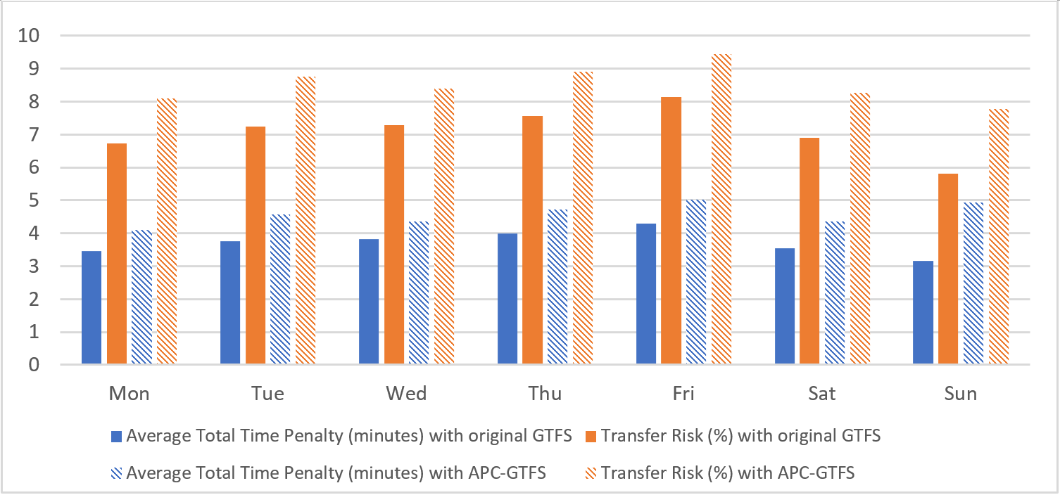

Figure 8 Overall Weekday TR and ATTP Trend Chart in 2018.

Figure 9 illustrates the hourly trend and Figure 10 maps the spatial patterns during time penalty periods when transfer risk and penalties clusters are high: mornings (8:00 – 9:00 and 9:00 – 10:00), afternoon (17:00 – 18:00 and 18:00 – 19:00), and night hours (22:00 – 23:00 and 23:00 – 24:00) for APC-GTFS data. High risk and penalties during the morning and afternoon periods can be explained by overall traffic pattern during these busy hours. However, nighttime with lower traffic also witnesses high transfer risk and high total time penalty. While the risk of missing a transfer does not increase dramatically at night, the consequences (time penalties) are higher due to sparser scheduled services (see Figure 9 and Figure 10).

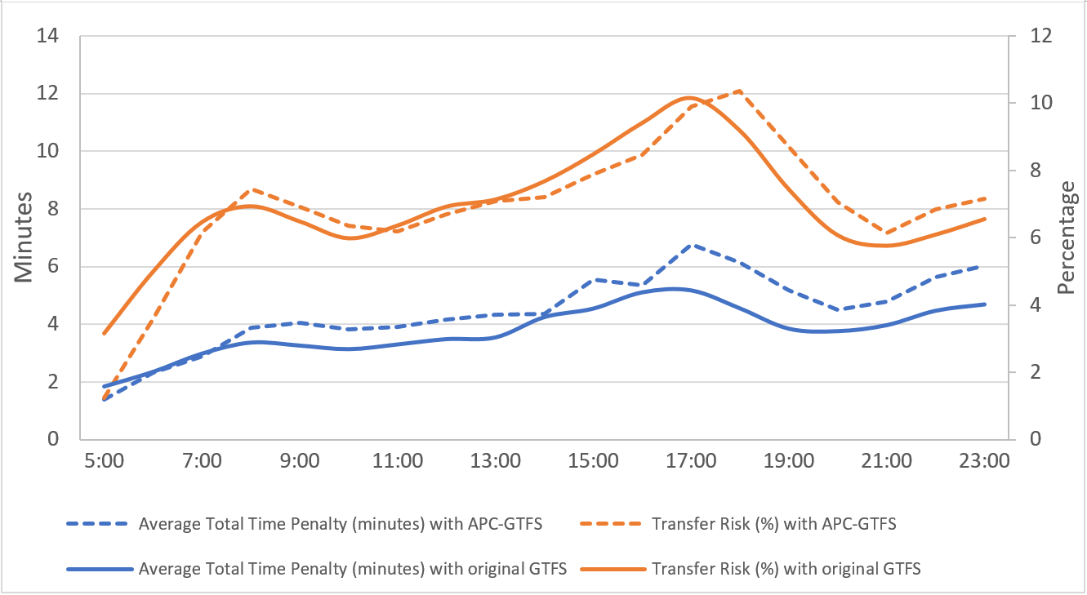

Figure 9 Overall Hourly TR and ATTP Trend Chart.

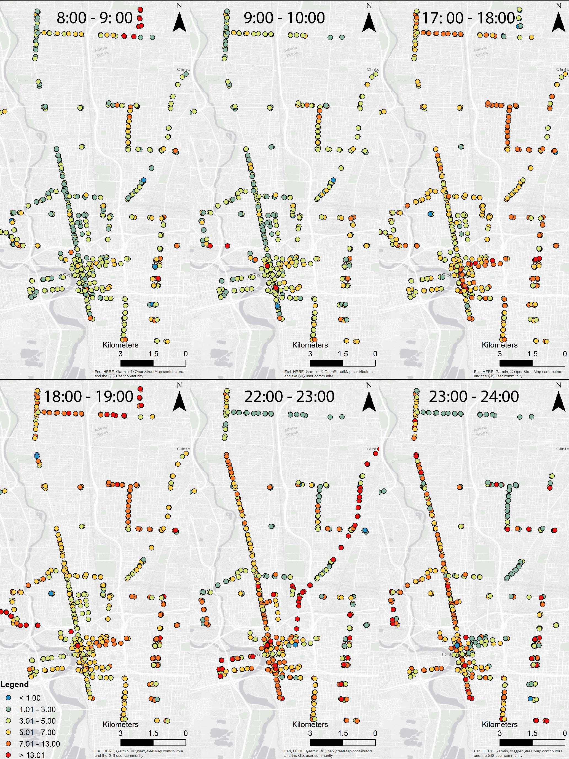

Figure 10 Average Total Time Penalty (ATTP, minutes) Hourly Temporal Pattern during three major high time periods with APC-GTFS.

As for the comparison of original GTFS and APC-GTFS, for most hours, APC-GTFS’s ATTP is larger than original GTFS’s; while only on rush hours (morning, afternoon, and night), APC-GTFS’s transfer risk is larger than GTFS’s. Figure 11 visualizes ATTP and TR’s difference between with APC-GTFS and with original GTFS. A clear pattern is the differences are larger during the rush hours. Although both results share highly identical spatiotemporal pattern, compared with APC-GTFS, which has higher temporal accuracy, original GTFS’s results are smaller especially during rush hours. Moreover, the differences will have more impact if ridership is included, since rush hours witness most ridership in the system. This demonstrates some risks of using original GTFS as the only data source without any calibration using administrative data.

11

Besides regular temporal patterns, we chose certain days with special events to see their impact on the transfer real-time performance. Weather, especially extreme weather during winter, is a major factor for public transit delays. Special events (such as football games near the Ohio State University in Columbus) can also impact local traffic and public transit. We selected several representative days to measure the TR and ATTP differences due to these events. We analyzed all days with more than 1.78 centimeters precipitation per day and all days with football games. During days with heavy precipitation, TR increases to 7.47% and ATTP increases to 3.92 minutes based on the original GTFS data; while TR increases to 9.89% and ATTP increases to 5.14 minutes based on the merged APC-GTFS data. During the football game days, TR increases to 8.66% and ATTP increases to 4.36 minutes based on the original GTFS data; TR increases to 9.06% and ATTP increases to 4.83 minutes based on the APC-GTFS data. Extreme weather and major events have considerable impact on the public transit transfer performance.

* 1. Simulating the impacts of dedicated bus lanes

*Dedicated bus lanes* (DBL) can provide benefits for a bus system by reducing delays due to automobile traffic. Without the disturbance of traffic congestion, bus rapid transit (BRT) systems with separated DBL can achieve rail-like performance (Li, Song, Li, & Zhang, 2009). Basso et al. (2011) investigated several congestion mitigating solutions and conclude that DBL is a good approach to diminish bus delays and increase on-time performance (Basso, Guevara, Gschwender, & Fuster, 2011).

We simulated the impact of DBL on delays, transfer risk and time penalties using the methods in this paper. First, we designated COTA bus route No. 2 as a dedicated bus route with several reasons:

* Frequent transfers: among all the routes, route No. 2 has the most transfers in the COTA system.
* Large spatial coverage: route No. 2 connect North Columbus and East Columbus with the downtown area, which spans a major part of the city.
* One of the busiest routes: Connecting Ohio State University and the downtown area, the ridership statistics show that No. 2 bus is among the routes with the highest ridership. From January 1st 2018 to January 17th 2018, transfers from and to the route 2 take 30.16% of total transfers, which is also the most among all the routes.
* High temporal frequency: route No. 2 is one of the most frequent route (10 – 15 minutes for standard schedule) among the bus routes in COTA system.

Based on these facts, we simulate the impact of a DBL by assume all the buses running on this route will behave according to the GTFS static schedule data after DBL is in effect (i.e., no delay). This is an upper bound on the actual DBL performance. We analyze TR and ATTP’s changing trend before and after applying the assumption and the difference’s spatial and temporal pattern.

We simulate the impact of a dedicated bus lane (DBL) transfer performance at proximal stops. We specifically inspected proximal stops’ TR and ATTP difference between the scenario without DBL and the scenario with DBL. Figure 12 shows spatial pattern of the TR and ATTP difference between no DBL and DBL on COTA Route 2. For transfer risk, the spatial pattern shows relatively random pattern of transfer risk changes. However, for ATTP, all stops’ performance universally improves but the impact on the downtown is less compared to other outlying stops. Across all stops and trips on the route, the DBL will save 1.69 minutes ( $σ=$ 13.24 minutes) with original GTFS; with APC-GTFS, the DBL will save 1.72 minutes ( $σ=$ 10.09 minutes). Therefore, although the average time savings is modest, the impacts are highly differentiated across stops.

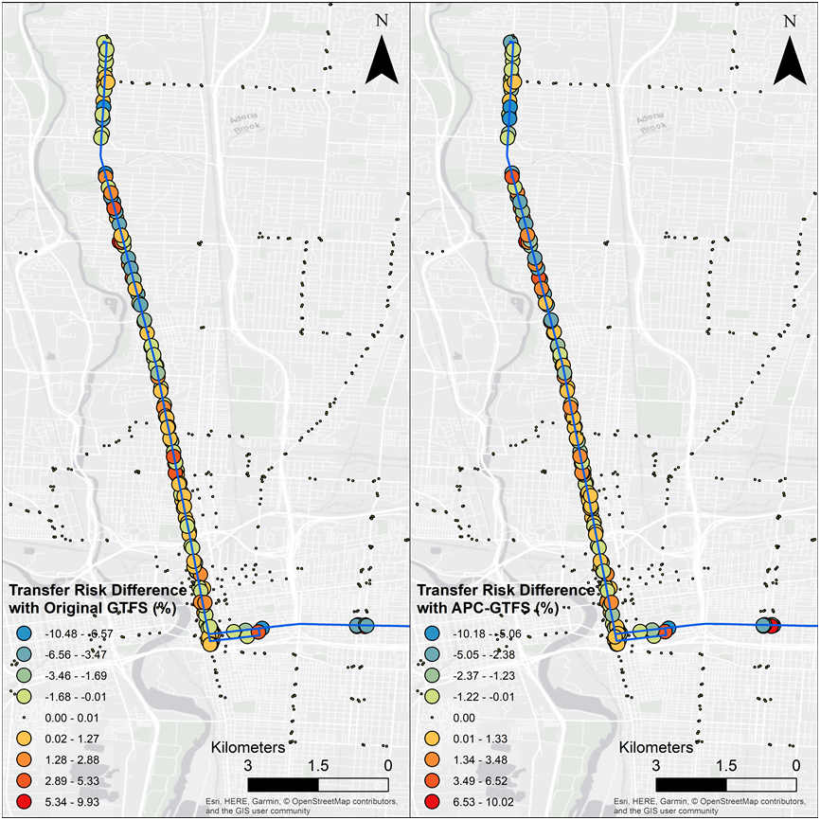

Figure 12 simulated differences in TR after implementation of a dedicated bus lane for original GTFS (left) and APC-GTFS (right)

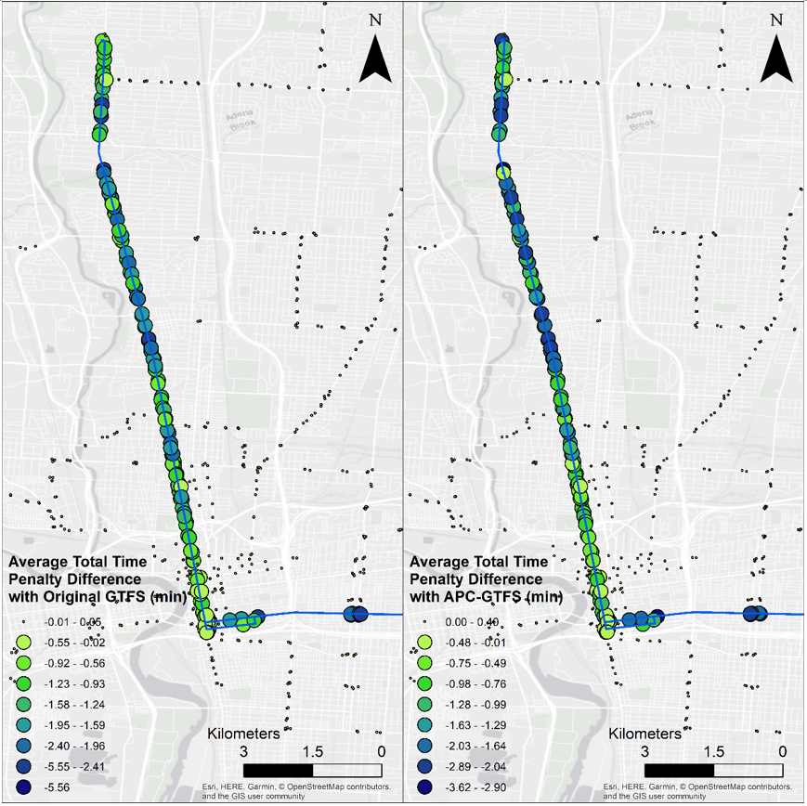

Figure simulated differences in ATTP after implementation of a dedicated bus lane for original GTFS (left) and APC-GTFS (right)

Besides DBL’s average impact on all trips, we calculated different impacts on the generating trips and receiving trips. We categorized all affected transfers into two classes: transfers with generating trip on the DBL (*DBL-generating transfers*) and transfers with receiving trip on the DBL (*DBL-receiving transfers*). According to Equation (3), TTP is determined by two factors: *ATP*, which represents the desynchronization penalty; and $d_{r}$, which represents normal bus delay. DBL will eliminate delays for all transfers and decrease all transfers’ total time penalty universally. Nevertheless, with DBL removing a generating trip’s delay, it will help reducing desynchronization during the transfer process. However, with DBL eliminating a receiving trip’s delay, it will increase desynchronization, but not necessarily enlarge the time penalty. To measure the two factors’ influence on the saved time, we specifically inspected TR difference and ATTP difference for DBL-generating and DBL-receiving transfers. By comparing the two measures, we investigated how DBL helps save time for the transit users.

Figure 14 shows that DBL will decrease desynchronization for DBL-generating transfers, while it will increase desynchronization for DBL-receiving transfers. This conclusion holds true for both datasets. The rationale behind this is: for a DBL-generating transfer, there is always a counterpart of DBL-receiving transfer. When DBL improves the performance of the DBL-generating transfer, it will degrade the performance of the DBL-receiving transfer simultaneously. As we combined the two classes of transfers, the graph suggests DBL will not significantly improve the overall TR performance.

However, the ATTP’s spatial and temporal pattern with original GTFS (Figure 12 and Figure 15) suggests the ATTP of stops on the DBL will universally decrease for both DBL-generating and DBL-receiving transfers; APC-GTFS’s results also show similar patterns. This moreover suggests that for the average TTP of the COTA system, $d_{r}$ is the dominating factors after implementing the DBL (see Equation (5)). Also, since DBL-generating transfers benefit from both less desynchronization and less delay, they save more time than the average; since desynchronization increases for DBL-receiving transfers, they still generally save time but less than the average.

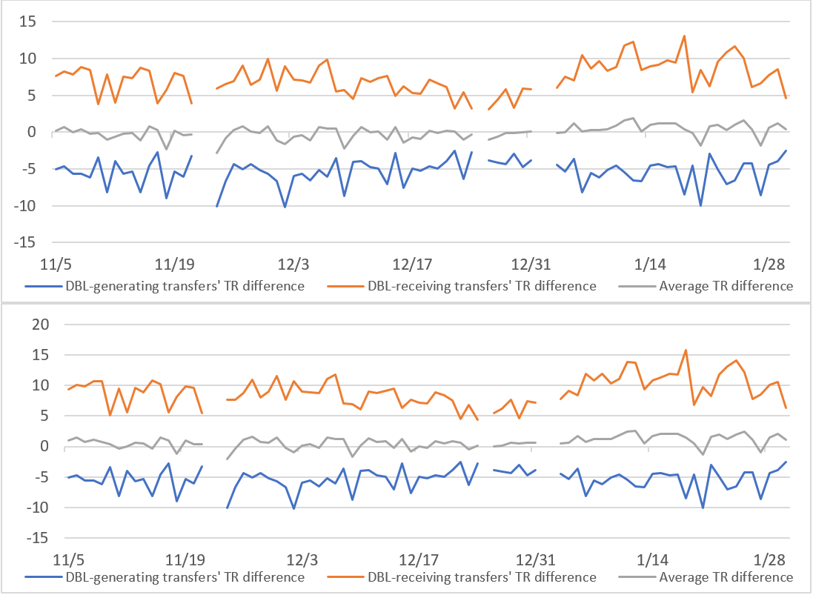

Figure 14 Temporal pattern of simulated changes in TR after implementing a dedicated bus lane with original GTFS (up) and APC-GTFS (down) (gaps indicate missing data)

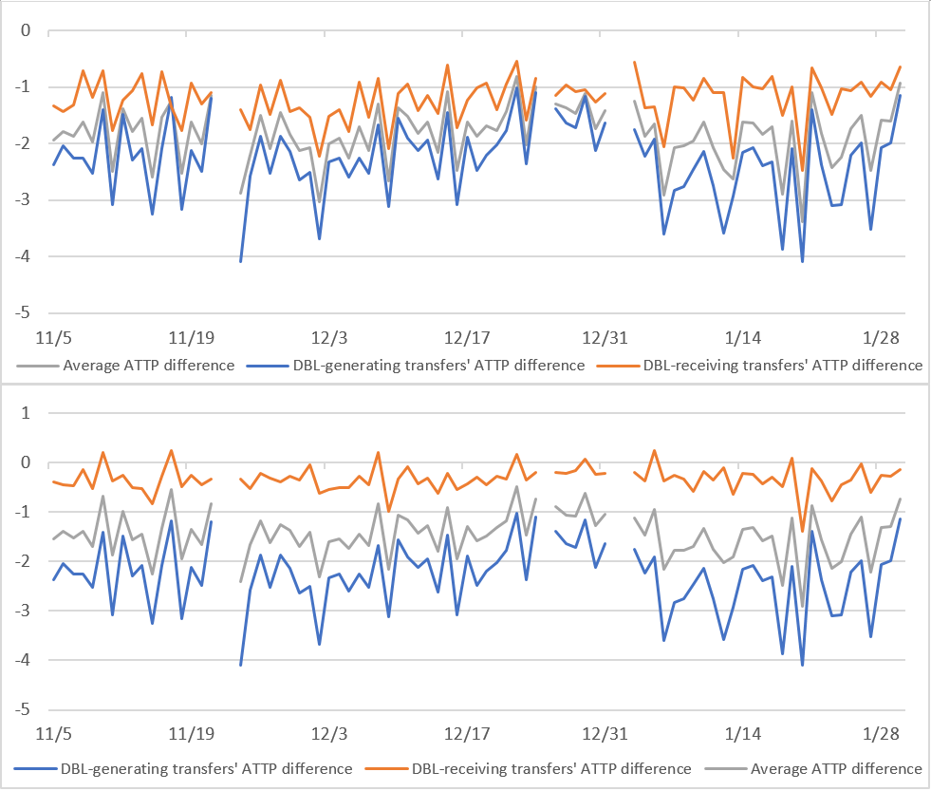

Figure 15 Temporal pattern of simulated changes in ATTP after implementing a dedicated bus lane with original GTFS (up) and APC-GTFS (down) (gaps correspond to missing data)

Based on this simulation, we conclude that DBL is a good strategy to decrease transfer users’ total time penalty. Figure 14 and Figure 15 also demonstrate that: synchronization is generally complicated to optimize for both transfers. However, delay is easy to optimize for both transfers. Although DBL only improves certain transfers’ TR performance, it will universally reduce transit system users’ total transfer time by systematically lessening the receiving buses’ delay. More generally, to optimize TTP, it is feasible and effective to reduce delay, such as dedicated bus lane and traffic control. The case study also shows that even if just a single route, instead of the whole system, delay control can be effective to reduce ATTP.

1. **Conclusion**

Transfers between routes are an essential issue for public transit design and operations, however, few studies focus on the transfers’ on-time performance in the real-time context. Based on high-resolution GTFS and APC real-time and static data of huge volume, we developed a series of measures, including the transfer risk (TR) and average total time penalty (ATTP), to assess the transfers’ performance. TR and ATTP indicate the systematic quality of transfers and corresponding potential time cost. These measurements provide important information for the transit system planners and administrators concerning the transfers’ feasibility, quality, and user experience. To illustrate this, we applied the indexes with two datasets in Columbus, Ohio: original GTFS data (February 2018 - January 2019) and APC-GTFS data (May 2018 - January 2019) with higher temporal accuracy. The spatial and temporal analysis show similar pattern like overall traffic and transit system delay, while it also shows some unique patterns, such as high time penalty during the nighttime due to larger headway. The comparison between original GTFS and APC-GTFS datasets furthermore demonstrates that it is possible to underestimate two indexes with only original GTFS data. Additionally, we simulated dedicated bus routes’ impact on the transfer performance. It suggests the dedicated bus lane is a good strategy to reduce ATTP, especially for DBL-generating transfers. We also conclude that it is generally effective to control delay, instead of synchronization, to reduce ATTP.

Future research direction can concentrate on the application of both smart and human sensors, generating abundant and high-resolution big data for analysis, administration and prediction. In this paper, we compared datasets of different temporal accuracy, nevertheless, we do not have a good answer for how spatial accuracy will influence the results and how the overall impact of inaccuracy can be decomposed into the two factors. It may be useful to utilize a third-party data to calibrate the GTFS data, so that GTFS data can achieve higher accuracy. Volunteered data from humans is also a possible strategy for collecting data (Bakillah, Liang, & Zipf, 2012). Based on more precise and abundant data, there are more possibilities for more scientific planning, improvement and knowledge derivation of transfer activities and the transit system. Moreover, with transfer ridership data, population and rider factors can be incorporated into the system (see the Appendix).

Optimization of real-time synchronization is another research gap that can be addressed in future research. There are already efforts to solve the synchronization optimization problem. For example, Ceder, Golany, & Tal (2001) developed a heuristic algorithm to maximize the timetable synchronization for a transit system’s schedule. However, few papers provide attainable solutions for real-time PT timetable synchronization. Based on the two introduced indexes, the real-time optimization problem can be properly defined and addressed.

**Appendix**

This appendix shows how to modify the TR and ATTP measures based on empirical ridership data. This allows the analyst to weight the risk and time penalty indexes based on the passengers impacted:

|  |  |  |
| --- | --- | --- |
|  | $$TR=E\left(a_{i}\right)=\frac{1}{n}\sum_{i=1}^{n}{a_{i}∙p_{i}}=\frac{1}{n∙\sum_{i=1}^{n}{r_{i}}}\sum_{i=1}^{n}{a_{i}∙r_{i}}$$ | (7) |

|  |  |  |
| --- | --- | --- |
|  |  | (8) |

where: $r_{i}$ is the number of people who use this transfer.

**References**

Algers, S., Hansen, S., & Tegner, G. (1975). Role of waiting time, comfort, and convenience in modal choice for work trip. *Transportation Research Record*, *534*, 38–51.

Antrim, A., & Barbeau, S. J. (2013). The many uses of GTFS data–opening the door to transit and multimodal applications. *Location-Aware Information Systems Laboratory at the University of South Florida*, *4*.

Ayed, A. Ben, Halima, M. Ben, & Alimi, A. M. (2015). Big data analytics for logistics and transportation. In *2015 4th International Conference on Advanced Logistics and Transport (ICALT)* (pp. 311–316). IEEE.

Bakillah, M., Liang, S. H. L., & Zipf, A. (2012). Toward coupling sensor data and Volunteered Geographic Information (VGI) with agent-based transport simulation in the context of smart cities. In *Proceedings of the First ACM SIGSPATIAL Workshop on Sensor Web Enablement* (pp. 17–23). ACM.

Bamford, C. G., Carrick, R. J., & MacDonald, R. (1984). Public transport surveys: A new effective technique of data collection. *Traffic Engineering & Control*, *25*(HS-037 547).

Basso, L. J., Guevara, C. A., Gschwender, A., & Fuster, M. (2011). Congestion pricing, transit subsidies and dedicated bus lanes: Efficient and practical solutions to congestion. *Transport Policy*, *18*(5), 676–684.

Ceder, A. (2007). *Public transit planning and operation: Modeling, practice and behavior*. CRC press.

Ceder, A., Golany, B., & Tal, O. (2001). Creating bus timetables with maximal synchronization. *Transportation Research Part A: Policy and Practice*, *35*(10), 913–928.

Chen, M., Mao, S., & Liu, Y. (2014). Big data: A survey. *Mobile Networks and Applications*, *19*(2), 171–209.

Chu, X. (2010). *A guidebook for using automatic passenger counter data for national transit database (NTD) reporting.* National Center for Transit Research (US).

Dessouky, M., Hall, R., Nowroozi, A., & Mourikas, K. (1999). Bus dispatching at timed transfer transit stations using bus tracking technology. *Transportation Research Part C: Emerging Technologies*, *7*(4), 187–208.

Google Developers. (2016). GTFS Static Overview | Static Transit | Google Developers. Retrieved March 8, 2018, from https://developers.google.com/transit/gtfs/

Google Developers. (2018). Trip Updates. Retrieved April 8, 2019, from https://developers.google.com/transit/gtfs-realtime/guides/trip-updates

Guo, Z., & Wilson, N. (2004). Assessment of the Transfer Penalty for Transit Trips Geographic Information System-Based Disaggregate Modeling Approach. *Transportation Research Record: Journal of the Transportation Research Board*, *1872*(1872), 10–18. https://doi.org/10.3141/1872-02

Guo, Z., & Wilson, N. H. M. (2011). Assessing the cost of transfer inconvenience in public transport systems: A case study of the London Underground. *Transportation Research Part A: Policy and Practice*, *45*(2), 91–104. https://doi.org/10.1016/j.tra.2010.11.002

Hadas, Y., & Ranjitkar, P. (2012). Modeling public-transit connectivity with spatial quality-of-transfer measurements. *Journal of Transport Geography*, *22*, 137–147.

Han, A. F. (1987). Assessment of Transfer Penalty to Bus Riders in Taipei: A Disaggregate Demand Modeling Approach. *Transportation Research Record*, *1139*(Table 1), 8–14.

Hunt, J. (1990). *A logit model of public transport route choice* (Vol. 60).

Ibarra-Rojas, O. J., & Rios-Solis, Y. A. (2012). Synchronization of bus timetabling. *Transportation Research Part B: Methodological*, *46*(5), 599–614.

Iseki, H., & Taylor, B. D. (2009). Not all transfers are created equal: Towards a framework relating transfer connectivity to travel behaviour. *Transport Reviews*, *29*(6), 777–800.

Jang, W. (2010). Travel time and transfer analysis using transit smart card data. *Transportation Research Record: Journal of the Transportation Research Board*, (2144), 142–149.

Knoppers, P., & Muller, T. (1995). Optimized transfer opportunities in public transport. *Transportation Science*, *29*(1), 101–105.

Kujala, R., Weckström, C., Mladenović, M. N., & Saramäki, J. (2018). Travel times and transfers in public transport: Comprehensive accessibility analysis based on Pareto-optimal journeys. *Computers, Environment and Urban Systems*, *67*, 41–54.

Li, J.-Q., Song, M., Li, M., & Zhang, W.-B. (2009). Planning for bus rapid transit in single dedicated bus lane. *Transportation Research Record: Journal of the Transportation Research Board*, (2111), 76–82.

Liu, R., Pendyala, R., & Polzin, S. (1997). Assessment of intermodal transfer penalties using stated preference data. *Transportation Research Record: Journal of the Transportation Research Board*, (1607), 74–80.

Liu, T., Ceder, A., Ma, J., Nesheli, M. M., & Guan, W. (2015). Optimal synchronized transfers in schedule-based public transport networks using online operational tactics. *Transportation Research Record: Journal of the Transportation Research Board*, (2533), 78–90.

Miller, H. J., & Goodchild, M. F. (2015). Data-driven geography. *GeoJournal*, *80*(4), 449–461.

Nesheli, M. M., & Ceder, A. A. (2014). Optimal combinations of selected tactics for public-transport transfer synchronization. *Transportation Research Part C: Emerging Technologies*, *48*, 491–504.

Nesheli, M. M., & Ceder, A. A. (2015). Improved reliability of public transportation using real-time transfer synchronization. *Transportation Research Part C: Emerging Technologies*, *60*, 525–539.

Nesheli, M. M., Ceder, A. A., & Liu, T. (2015). A robust, tactic-based, real-time framework for public-transport transfer synchronization. *Transportation Research Procedia*, *9*, 246–268.

Nesheli, M. M., Ceder, A., & Gonzalez, V. A. (2016). Real-time public-transport operational tactics using synchronized transfers to eliminate vehicle bunching. *IEEE Transactions on Intelligent Transportation Systems*, *17*(11), 3220–3229.

Nesheli, M. M., Cedera, A. A., & Hassold, S. (2014). *Optimal holding and skip-stop/segment tactics for public-transport transfer synchronization*.

Nishiuchi, H., Todoroki, T., & Kishi, Y. (2015). A Fundamental Study on Evaluation of Public Transport Transfer Nodes by Data Envelop Analysis Approach Using Smart Card Data. *Transportation Research Procedia*, *6*, 391–401.

Planning, C. T., & Transportation, U. S. D. of. (1997). *Transfer penalties in urban mode choice modeling*. US Dept. of Transportation.

Sun, L., Rong, J., Ren, F., & Yao, L. (2007). Evaluation of passenger transfer efficiency of an urban public transportation terminal. In *IEEE Conference on Intelligent Transportation Systems, Proceedings, ITSC* (pp. 436–441). IEEE. https://doi.org/10.1109/ITSC.2007.4357762

Sun, L., Rong, J., & Yao, L. (2010). Measuring Transfer Efficiency of Urban Public Transportation Terminals by Data Envelopment Analysis. *Journal of Urban Planning and Development*, *136*(4), 314–319. https://doi.org/10.1061/(ASCE)UP.1943-5444.0000028

Transit Wiki. (2019). Automated passenger counter. Retrieved February 10, 2019, from https://www.transitwiki.org/TransitWiki/index.php/Automated_passenger_counter

Transmodel. (2019). Standard Interface for Real-time Information. Retrieved from http://www.transmodel-cen.eu/standards/siri/

Walker, J. (2012). *Human transit: How clearer thinking about public transit can enrich our communities and our lives*. Island Press.

Wardman, M. (1998). A review of British evidence on the valuations of time and service quality.

Wardman, M., Hine, J., & Stradling, S. (2001). Interchange and Travel Choice Volume 2. *Scottish Executive Central Research Unit*.

1. * Corresponding author e-mail: [miller.81@osu.edu](mailto:miller.81@osu.edu)

   First author e-mail: [liu.6544@osu.edu](mailto:liu.6544@osu.edu)